AWS Project: Highly Available Web Application with Monitoring and Auto Scaling
Task 1: Create a VPC (N. Virginia - us-east-1)
Purpose
A VPC (Virtual Private Cloud) is your private network in AWS where all networking resources such as subnets, EC2 instances, route tables, and gateways are created.
Steps
- Sign in to the AWS Management Console.
- Select Region → N. Virginia (us-east-1).
- Open VPC Dashboard.
- Click Create VPC.
- Select VPC only.
- Enter:
  - Name: Project-VPC
  - IPv4 CIDR: 10.0.0.0/16
  - IPv6: None
  - Tenancy: Default
- Click Create VPC.
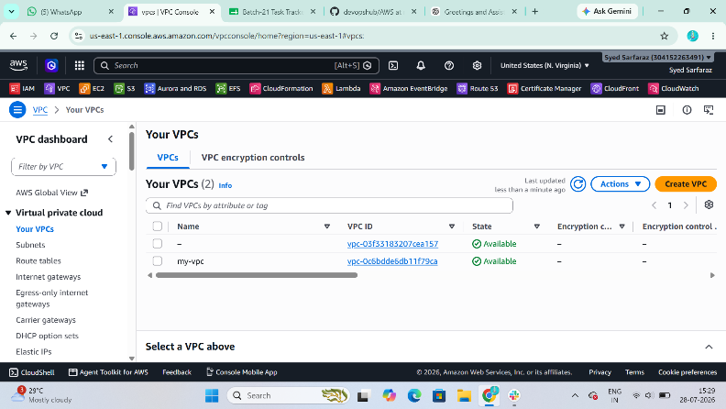

Task 2: Create Public and Private Subnets
Purpose
Subnets divide the VPC into separate networks.
- Public subnet allows internet access.
- Private subnet does not have direct internet access.
Steps
Public Subnet
- Open Subnets.
- Click Create subnet.
- Select Project-VPC.
- Enter:
  - Name: Public-Subnet
  - Availability Zone: us-east-1a
  - IPv4 CIDR: 10.0.1.0/24
- Click Create subnet.
Enable Auto Assign Public IP
- Select Public-Subnet.
- Choose Actions → Edit subnet settings.
- Enable Auto-assign public IPv4 address.
- Save.
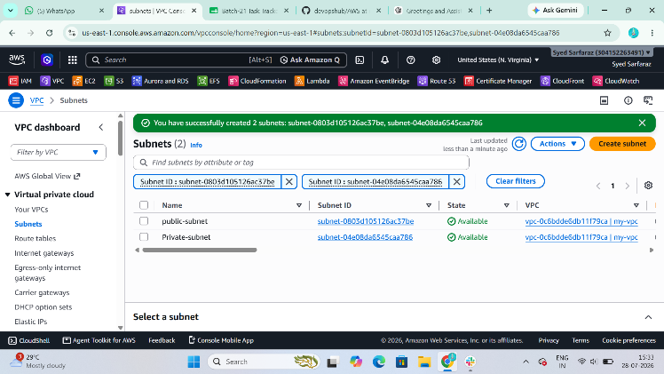

Private Subnet
- Click Create subnet.
- Select Project-VPC.
- Enter:
  - Name: Private-Subnet
  - Availability Zone: us-east-1b
  - IPv4 CIDR: 10.0.2.0/24
- Click Create subnet.

Task 3: Attach Internet Gateway (IGW)
Purpose
Internet Gateway allows resources in the public subnet to communicate with the internet.
Steps
- Open Internet Gateways.
- Click Create Internet Gateway.
- Name:
  - Project-IGW
- Click Create.
- Select the IGW.
- Click Actions → Attach to VPC.
- Select Project-VPC.
- Click Attach.
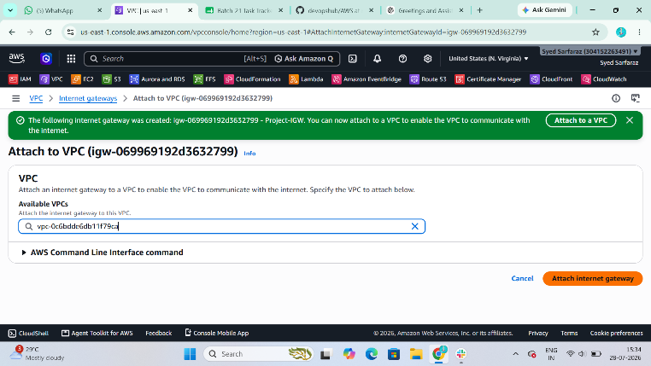

Task 4: Create Route Tables
Purpose
Route tables determine where network traffic is directed.
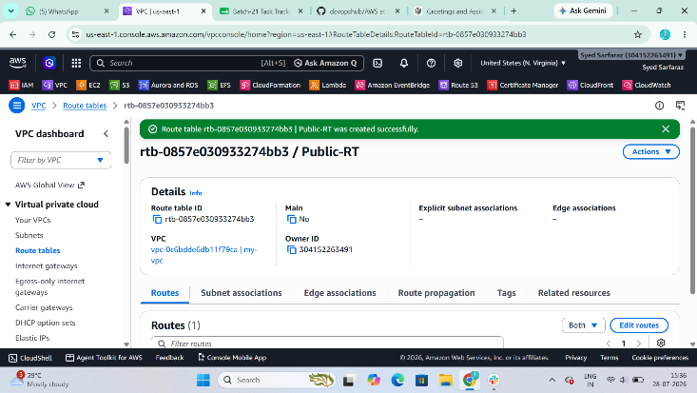

Public Route Table
Steps
- Open Route Tables.
- Click Create Route Table.
- Name:
  - Public-RT
- Select Project-VPC.
- Click Create.
Add Internet Route
- Select Public-RT.
- Go to Routes.
- Click Edit Routes.
- Add:
Destination | Target
0.0.0.0/0 | Internet Gateway
- Save.
Associate Public Subnet
- Open Subnet Associations.
- Click Edit Associations.
- Select Public-Subnet.
- Save.
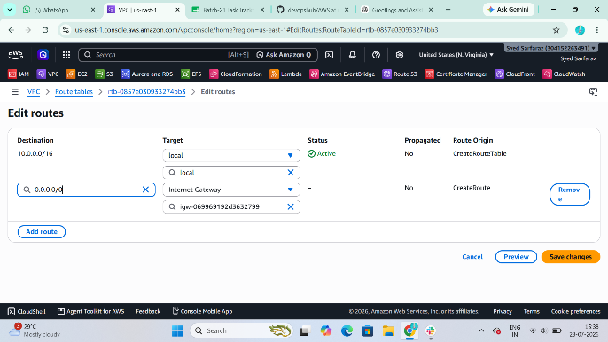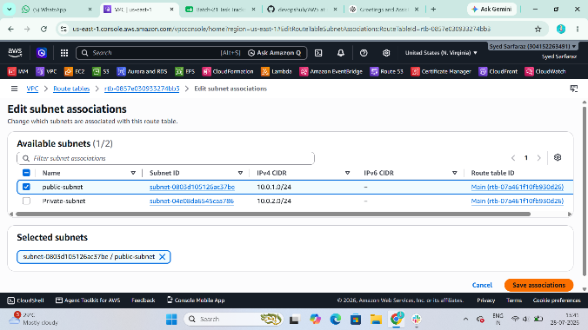

Private Route Table
Steps
- Create another Route Table.
- Name:
  - Private-RT
- Select Project-VPC.
- Click Create.
Associate Private-Subnet with this route table.
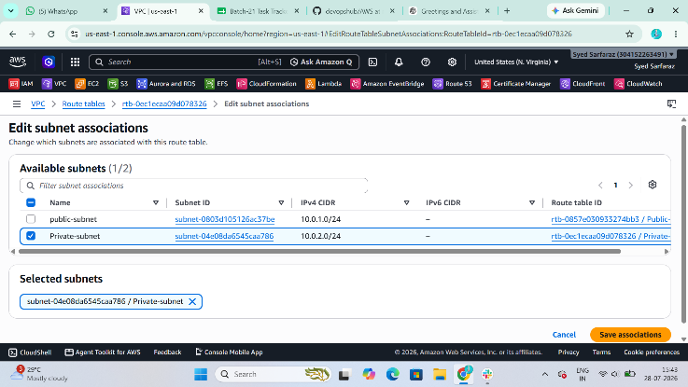

Task 5: Create NAT Gateway
Purpose
A NAT Gateway allows private EC2 instances to access the internet for updates and package installations without exposing them to inbound internet traffic.
Steps
- Open NAT Gateways.
- Click Create NAT Gateway.
- Enter:
  - Name: Project-NAT
  - Subnet: Public-Subnet
- Allocate a new Elastic IP.
- Click Create NAT Gateway.
- Wait until the status changes to Available.
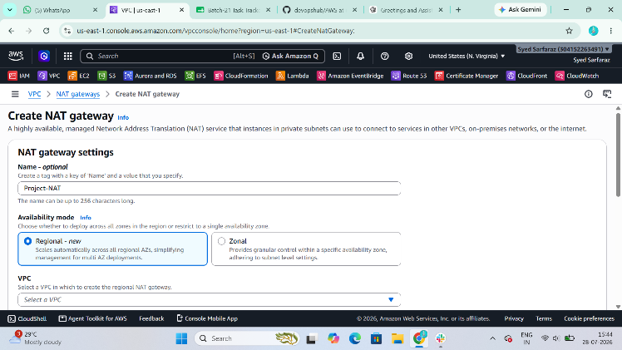

Update Private Route Table
- Open Private-RT.
- Go to Routes.
- Click Edit Routes.
- Add:
Destination | Target
0.0.0.0/0 | NAT Gateway
- Save.
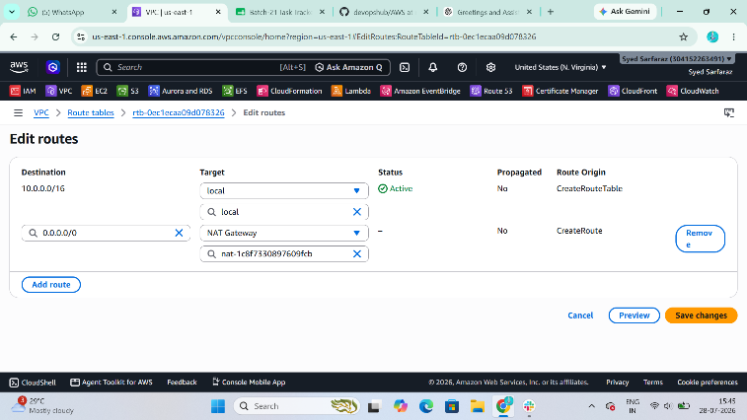

Task 6: Launch EC2 Instances
Purpose
Deploy one web server in the public subnet and one web server in the private subnet.

Public EC2
Launch an instance with:
- Name: Public-Web
- AMI: Amazon Linux 2023
- Instance Type: t2.micro
- VPC: Project-VPC
- Subnet: Public-Subnet
- Auto Assign Public IP: Enable
- Security Group:
  - SSH (22) from My IP
  - HTTP (80) from Anywhere
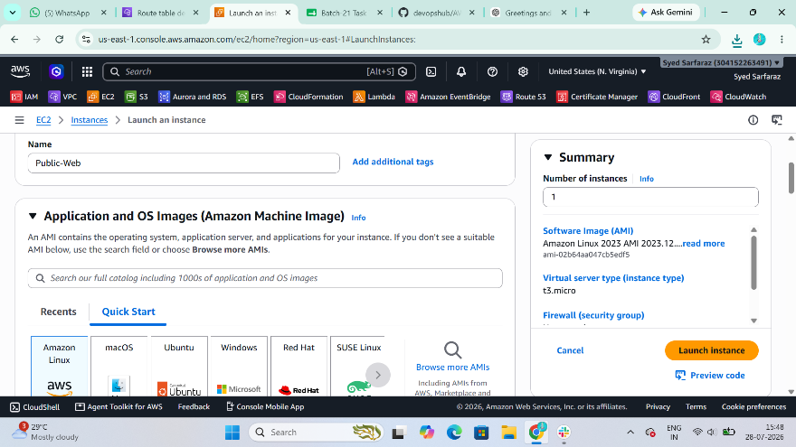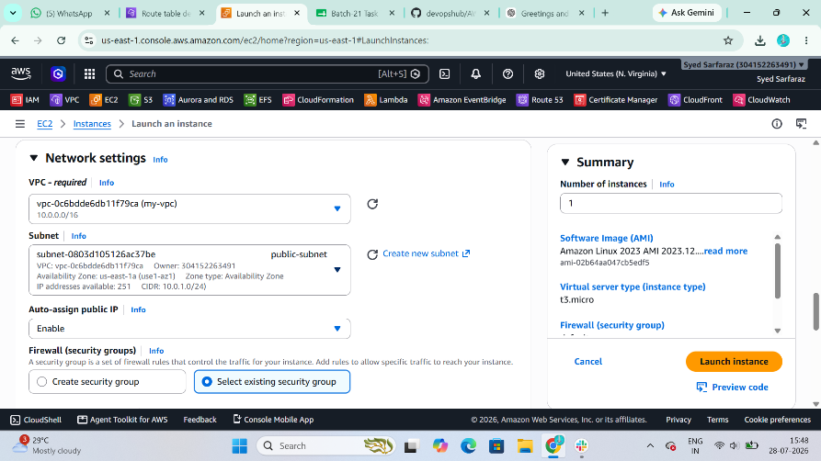

Private EC2
Launch another instance:
- Name: Private-Web
- Same AMI
- Same Instance Type
- VPC: Project-VPC
- Subnet: Private-Subnet
- Public IP: Disabled
- Security Group:
  - SSH from Bastion/Public EC2 Security Group
  - HTTP from ALB Security Group
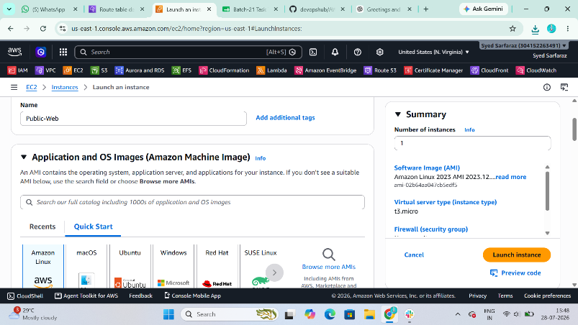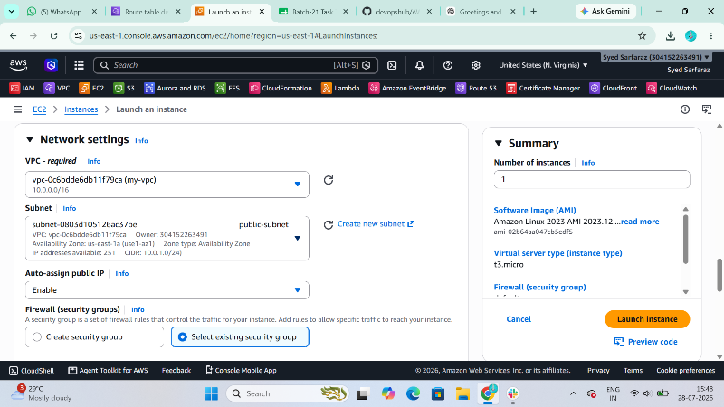

Task 7: Install Apache on Both EC2 Instances
Purpose
Deploy a simple web application.
Commands
sudo dnf update -y
sudo dnf install httpd -y
sudo systemctl enable httpd
sudo systemctl start httpd

echo "<h1>Apache Server Running on $(hostname)</h1>" | sudo tee /var/www/html/index.html
Verify:
systemctl status httpd
Public Instance
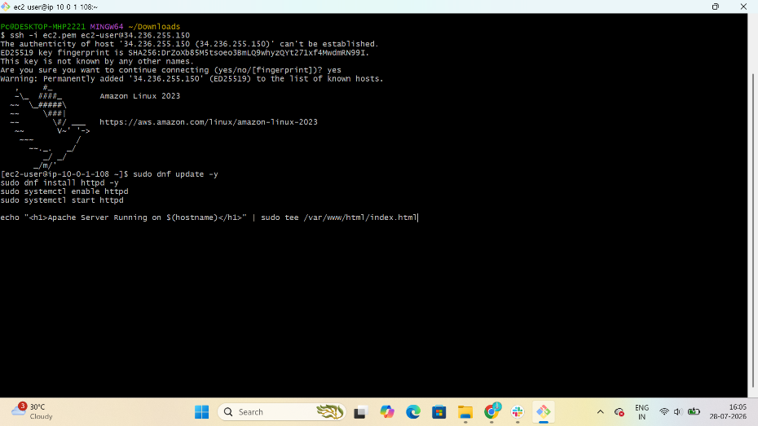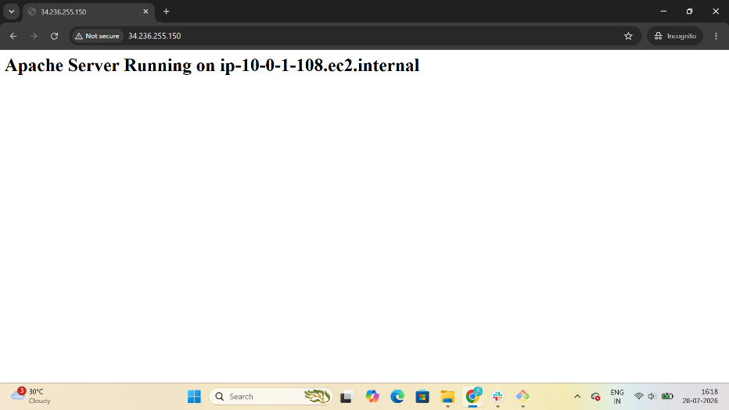

Private Instance
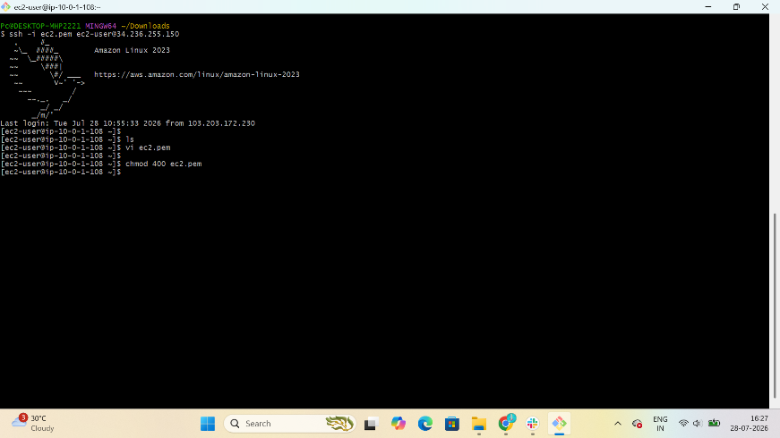
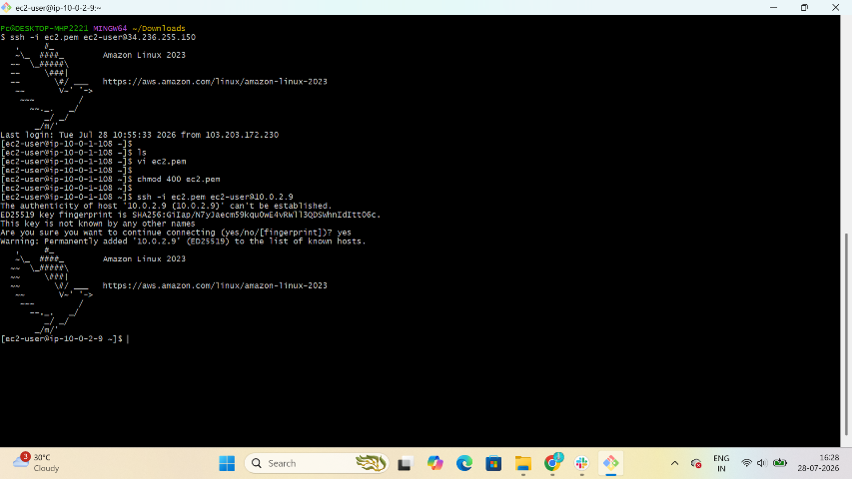
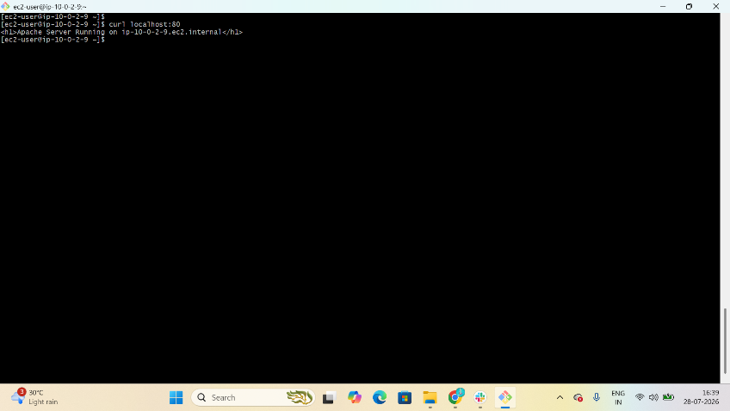

Task 8: Create Application Load Balancer (ALB)
Purpose
Distribute incoming HTTP traffic across multiple EC2 instances.
Steps
- Open EC2 → Load Balancers.
- Click Create Load Balancer.
- Select Application Load Balancer.
- Configure:
  - Name: Project-ALB
  - Scheme: Internet-facing
  - IP Type: IPv4
- Select:
  - VPC: Project-VPC
  - Availability Zones:
    - Public-Subnet
- Create a Security Group:
  - HTTP (80) from Anywhere
- Create a Target Group:
  - Target Type: Instances
  - Protocol: HTTP
  - Port: 80
- Register:
  - Public-Web
  - Private-Web
- Create the Load Balancer.
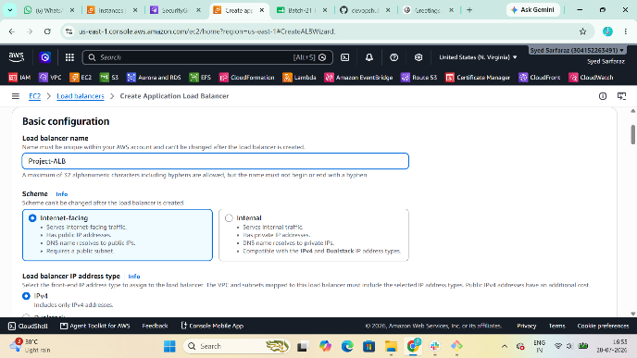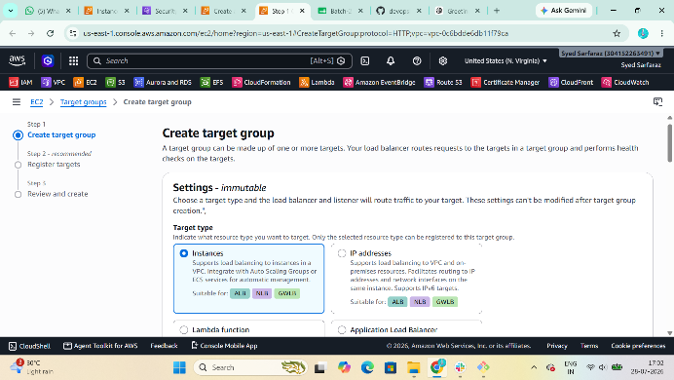
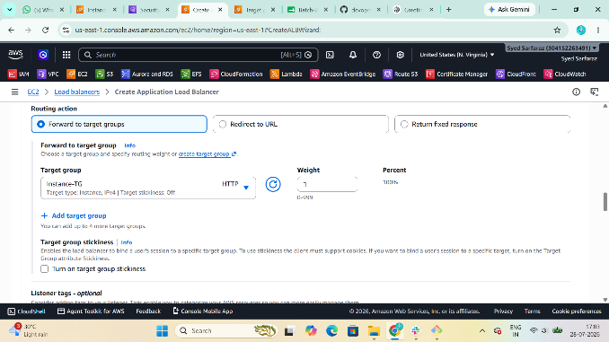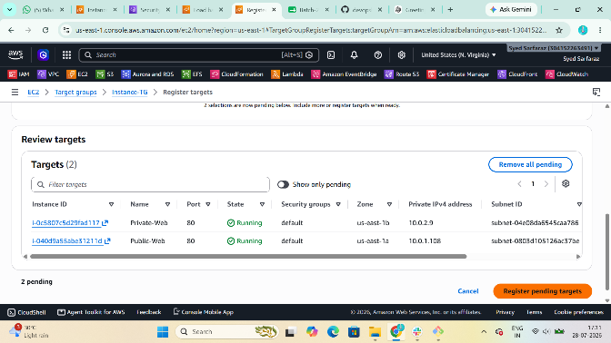
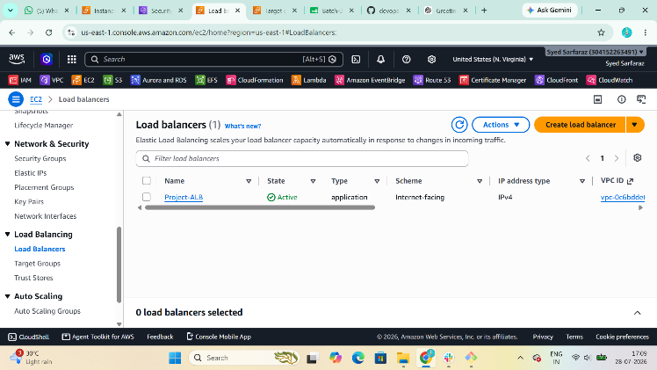
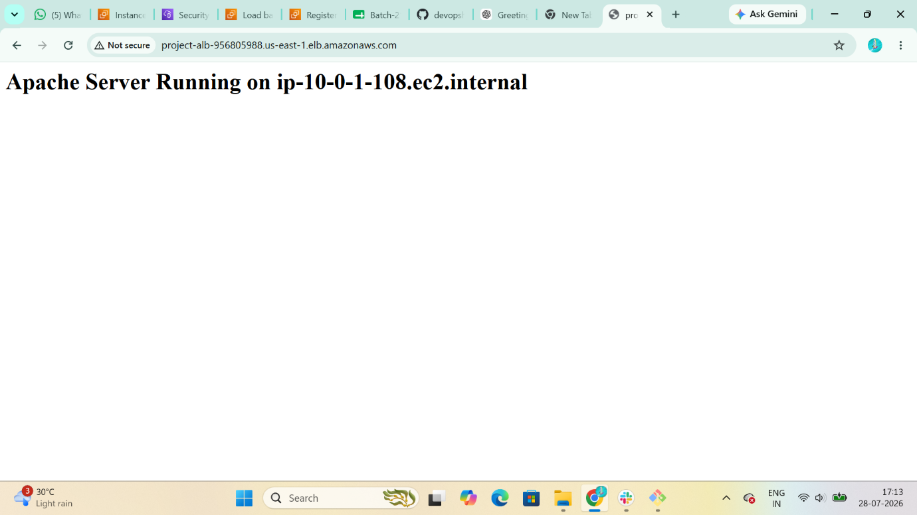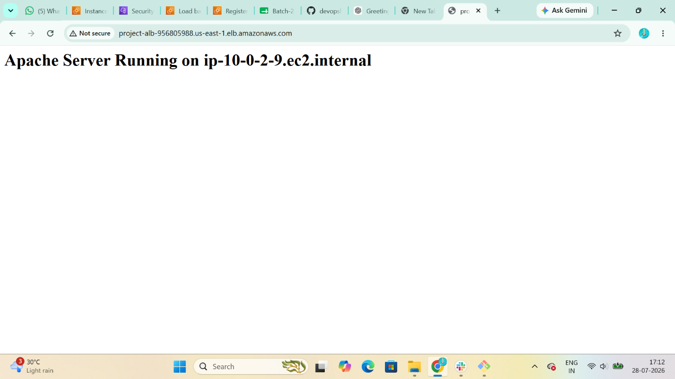

Task 9: Store ALB Logs in S3
Purpose
Store access logs generated by the Application Load Balancer for auditing and troubleshooting.
Steps
- Create an S3 bucket:
  - Example: project-alb-logs-<unique-name>
- Add the required bucket policy to allow ALB to write logs.
- Open the ALB.
- Go to Attributes.
- Enable Access Logs.
- Select the S3 bucket.
- Save changes.
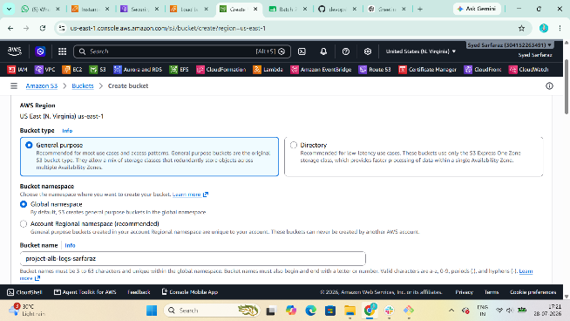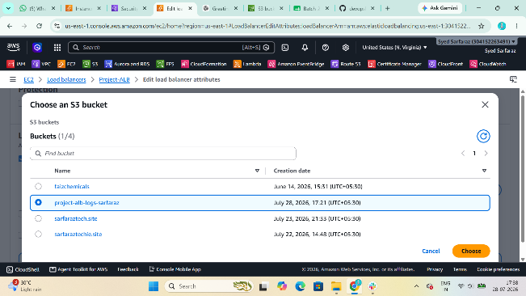
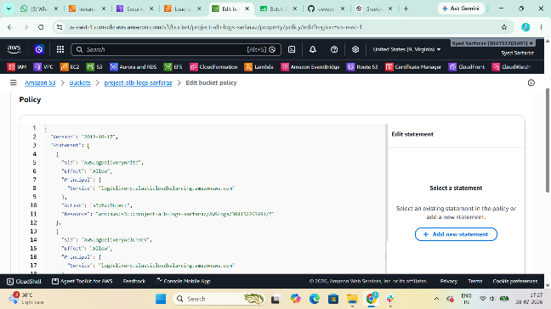

alb-logs/
└── AWSLogs/
└── 123456789012/
└── elasticloadbalancing/
└── us-east-1/
└── 2026/
└── 07/
└── 28/
├── log-file-1.gz
├── log-file-2.gz
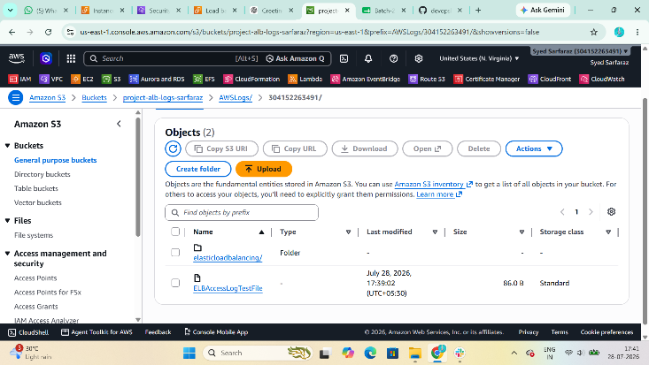

Task 10: Store VPC Flow Logs in CloudWatch
Purpose
Capture network traffic information for monitoring and troubleshooting.
Steps
- Create a CloudWatch Log Group:
  - Project-VPC-FlowLogs
- Create an IAM role for VPC Flow Logs with permissions to write to CloudWatch Logs.
- Open the VPC.
- Go to Flow Logs.
- Click Create Flow Log.
- Configure:
  - Filter: All
  - Destination: CloudWatch Logs
  - Log Group: Project-VPC-FlowLogs
  - IAM Role: Select the created role
- Create the flow log.
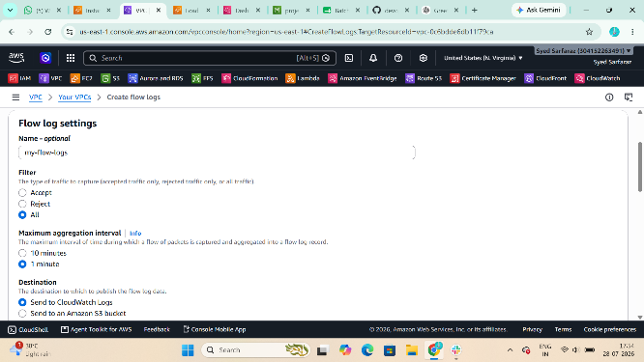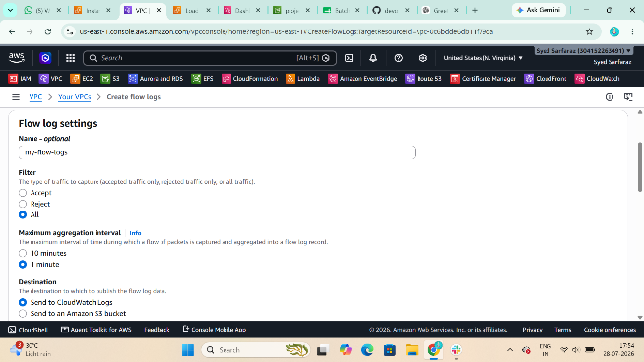
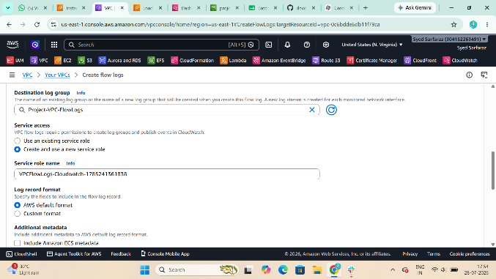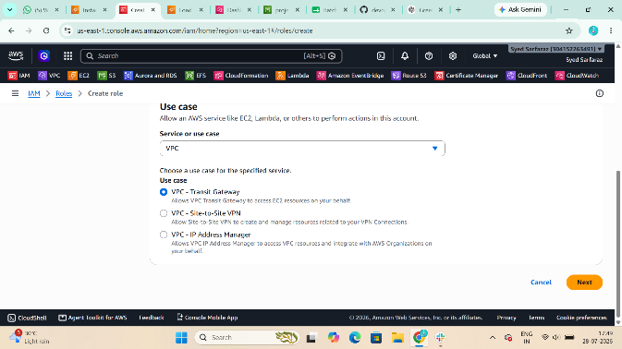
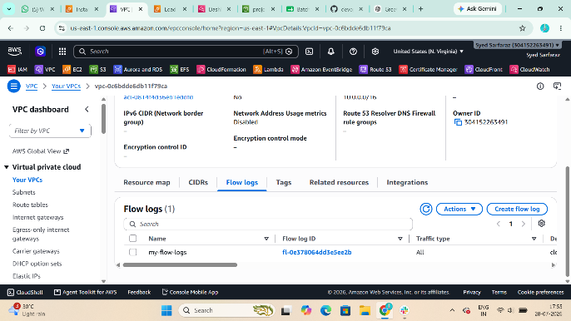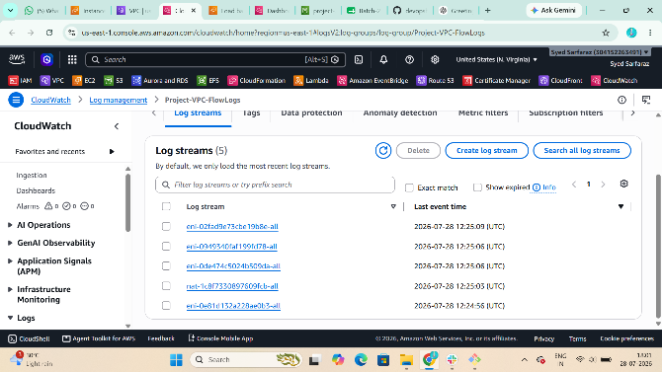

Task 11: Create CloudWatch Dashboards
Purpose
Monitor EC2 CPU utilization and Apache service.
CPU Utilization Dashboard
- Open CloudWatch → Dashboards.
- Click Create Dashboard.
- Name it:
  - Project-Dashboard
- Add a widget:
  - Metric → EC2 → Per-Instance Metrics
  - Select CPUUtilization for all web servers.
- Save the dashboard.
Apache Monitoring
- Install the CloudWatch Agent on each EC2 instance.
- Configure the agent to collect metrics and logs for the Apache (httpd) service.
- Start the CloudWatch Agent.
- Add the collected metrics or logs to the CloudWatch dashboard to monitor Apache.
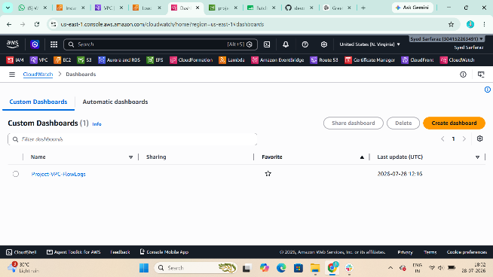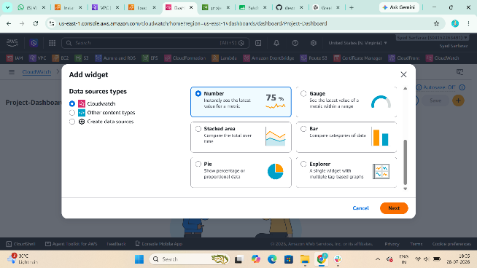
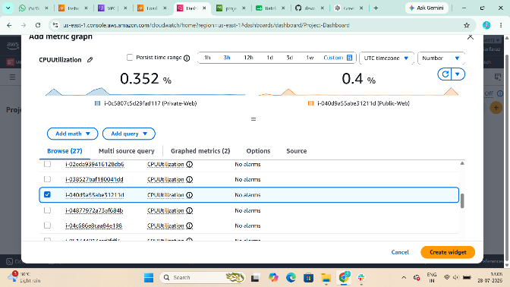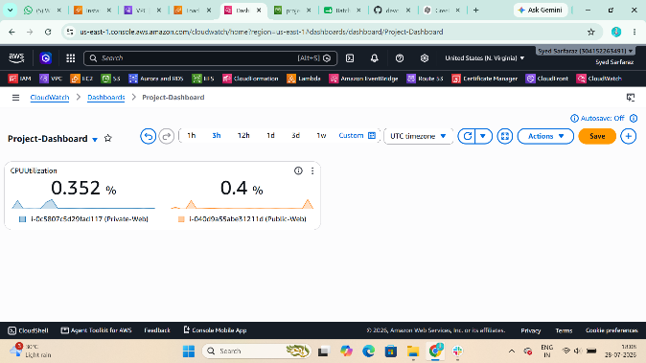

Task 12: Auto Scaling Based on CPU > 70%
Purpose
Automatically launch new EC2 instances when CPU utilization exceeds 70% to maintain application availability.
Steps
- Create an AMI from the configured Apache EC2 instance.
- Create a Launch Template:
  - AMI: Apache server AMI
  - Instance Type: t2.micro
  - Security Group: Web Server Security Group
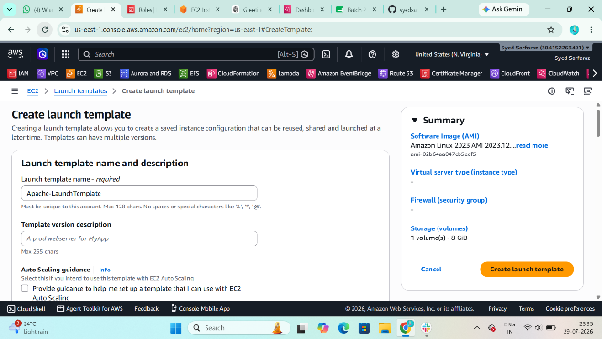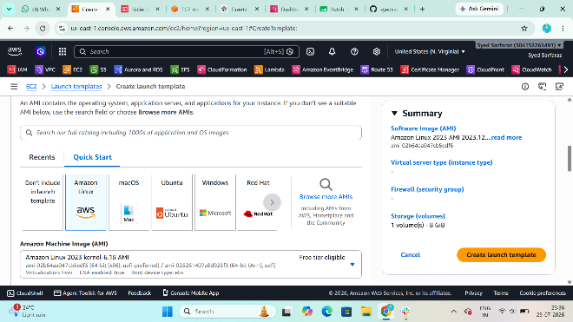

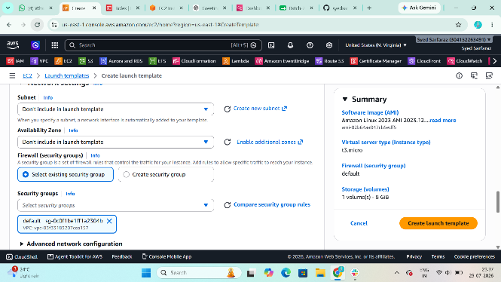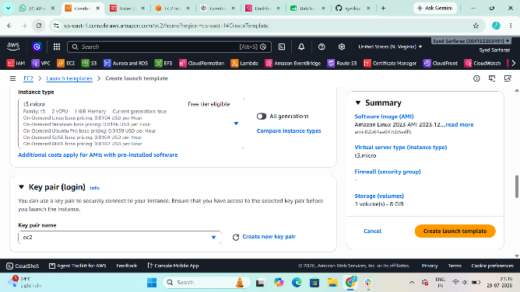
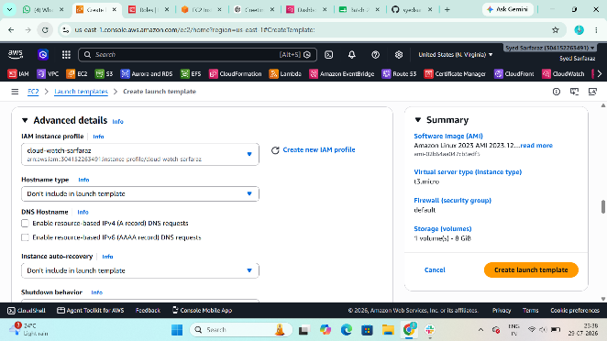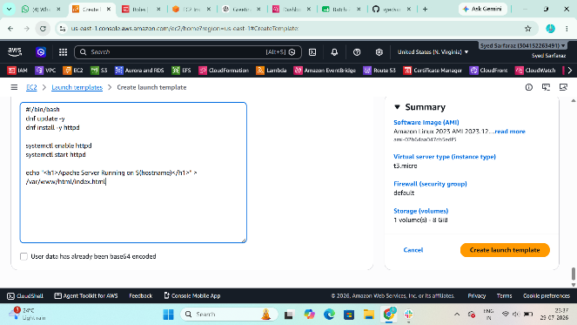
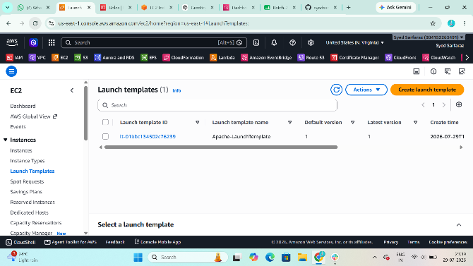
- Create an Auto Scaling Group:
  - VPC: Project-VPC
  - Subnets: Public-Subnet and Private-Subnet (or the desired application subnets)
  - Attach the existing Application Load Balancer target group.
- Set:
  - Desired Capacity: 2
  - Minimum Capacity: 2
  - Maximum Capacity: 4
- Add a target tracking scaling policy:
  - Metric: Average CPU Utilization
  - Target Value: 70%
- Create the Auto Scaling Group.
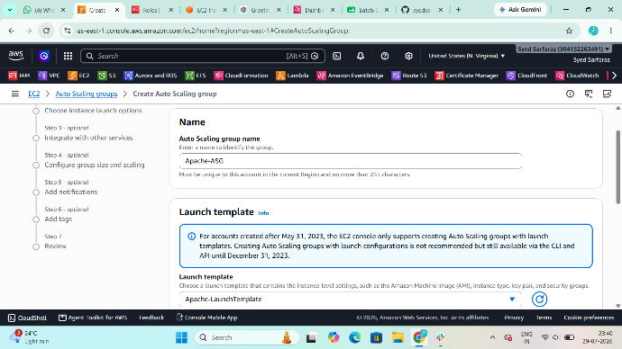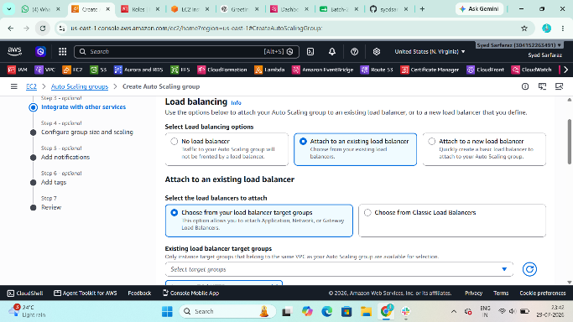
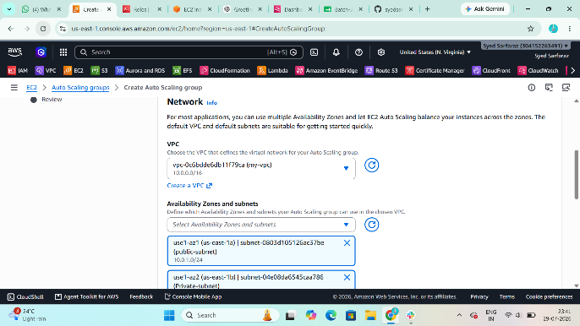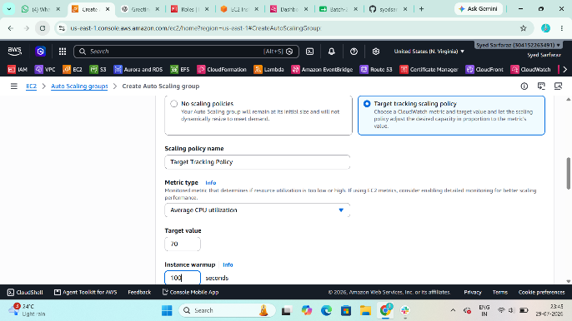
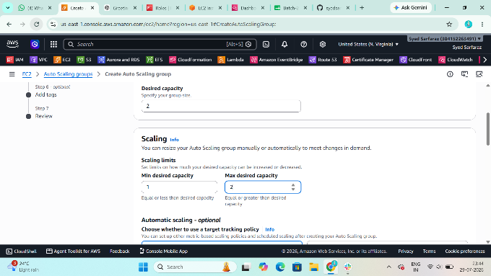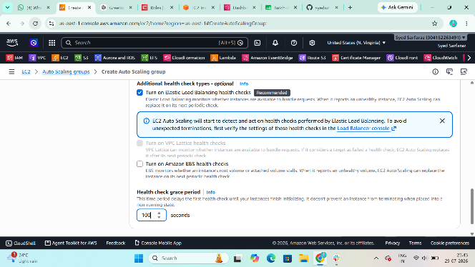
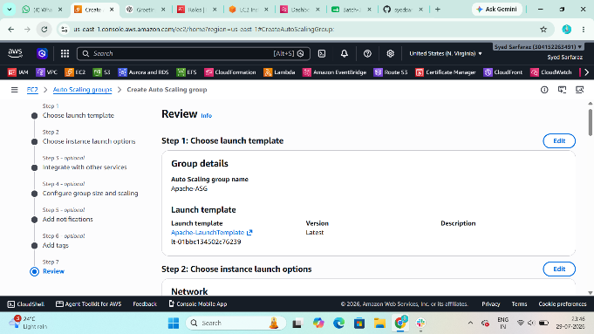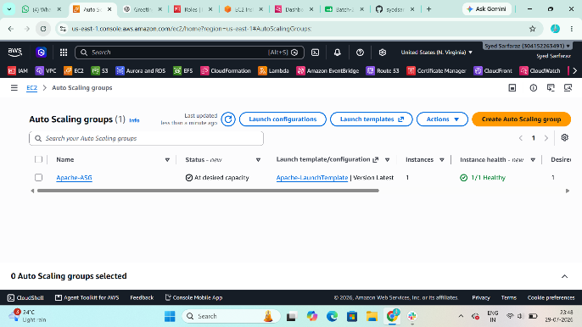
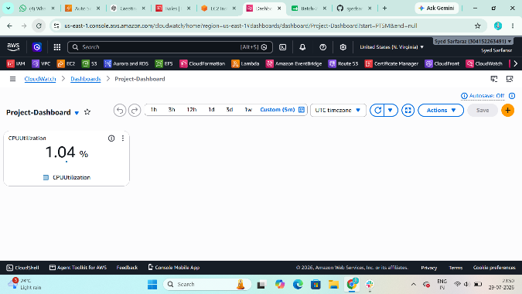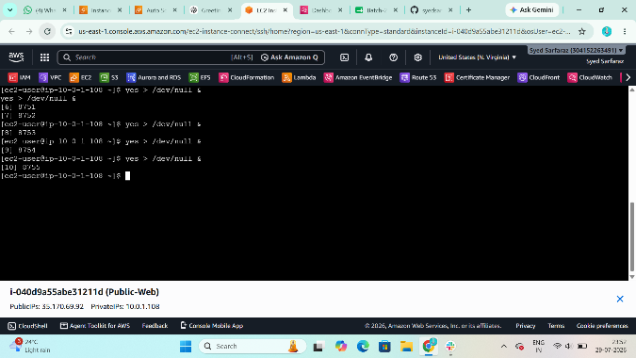
AWS will automatically launch additional EC2 instances when the average CPU utilization exceeds 70% and terminate extra instances when the load decreases.
